I. CHOOSE THE CORRECT ANSWERS:
1. Write the following statement in the form of an equation:
The sum of three times x and 3 is 18.
(a) 3x + 3 = 18 (b) 3x – 3 = 18 (c) 3x + 18 = 3 (d) none of these
2. The solution of the equation 7n + 5 = 12 is
(a) 0 (b) – 1 (c) 1 (d) 5
3. The measure of each angle of an equilateral triangle is
(a) 30° (b) 45° (c) 90° (d) 60°
4. The ratio of the measures of the three angles of a triangle is 2 : 3 : 4. The measure of the smallest angle is
(a) 80° (b) 60° (c) 40° (d) 180°
5. In the following figure, the side BC of ∆ ABC is extended up to the point D. If ∠A = 55° and ∠B = 60°, then the measure of ∠ACD is
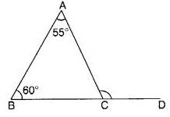
(a) 120° (b) 110° (c) 115° (d) 125°

II. FIND THE SOLUTION OF THE FOLLOWING QUESTIONS (any four):
6. Write equations for the following statements:
(i) The sum of numbers x and 4 is 9.
(ii) Three-fourth of t is 15
7. Solve the following equations:
(i) 4 = 5(p- 2)
(ii) 4x+9 = 3x-12
8. Set up equations and solve to find the unknown numbers in the following:
Meena subtracts thrice the number of notebooks he has from 50, he finds the result to be 8.
9. Find the value of the unknown angle x in the following figure:
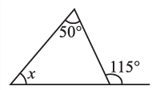
10. Find the value of the unknown x in the following diagram:
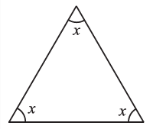

III. FIND THE SOLUTION OF THE FOLLOWING THREE MARKS (any five):
11. The teacher tells the class that the highest mark obtained by a student in her class is twice the lowest marks plus 7. The highest score is 87. What is the lowest score?
12. Laxmi’s father is 49 years old. He is 4 years older than three times Laxmi’s age. What is Laxmi’s age?
13. Solve the following equations:
(a) 16 = 4 + 3 (t + 2)
(b) 4 + 5(p – 1) = 34

14. Find the value of the unknown x in the following diagram:
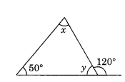
15. ABC is a triangle, right angled at C. If AB = 25 cm and AC = 7 cm, find BC.
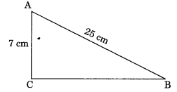
16. Solve the following equations:
$i. 2y+\frac{5}{2}=\frac{37}{2}$ $ii.\frac{a}{5}+3=2$
IV. FIND THE SOLUTION OF THE FOLLOWING FOUR MARK (ANY THREE):
17. A 15 m long ladder reached a window 12 m high from the ground on placing it against a wall at a distance a. Find the distance of the foot of the ladder from the wall.
18. Which of the following can be the sides of a right triangle?
(i) 3 cm, 4 cm, 5 cm.
(ii) 2 cm, 2 cm, 5 cm.
19. People of Sundargram planted trees in a village garden. Some of the trees were fruit trees. The number of non-fruit trees were two more than three times the number of fruit trees. What was the number of fruit trees planted if the number of non-fruit trees planted was 77?
20. Solve the following riddle:
I am a number,
Tell my identity!
Take me seven times over
And add a fifty!
To reach a triple century
You still need forty!

